Name: Zainab Azeem

Roll no: 21P-8025

Program: BCS

Task 12

Question no 1:

Part a:

Input

fo=open("names.txt","r") #open file

for i in fo:

i=i.strip("/n") #strip to remove space

i=i[0:4]

print(i)

Output

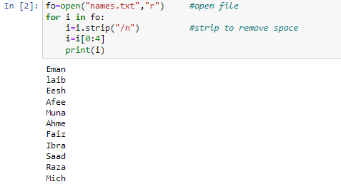

Part b:

Input

fo=open("names.txt","r") #open file

sum=0

for line in fo: #loop for length of file

sum+=len(line)

print(sum)

Output

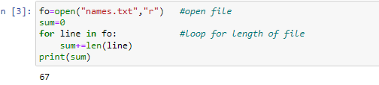

Part c:

Input

fo=open("names.txt","r") #open file in read mode

sum=0

counter=0

for line in fo:

sum+=len(line)

counter+=1 #counter for average

a=sum/counter

print(round(a,2))

Output

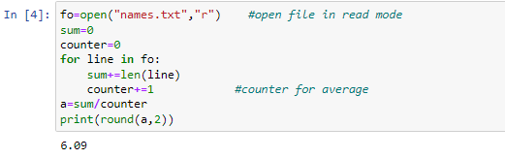

Part d:

Input

fo=open("names.txt","r") #open file

a=fo.readline()

for i in fo:

if len(i)<len(a): #consider first name as smallest name

b=i

a=i

print("shortest name",b)

Output

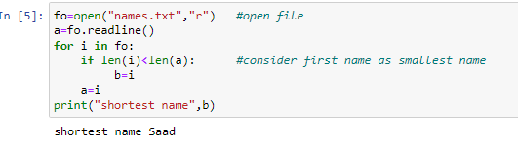

Part e:

Input

def print_name(n): #open file

fo=open("names.txt","r+")

for i in fo:

i=i.strip("\n")

a=len(i) #length of file

if a==n:

print(i)

b=int(input("enter number"))

print_name(b)

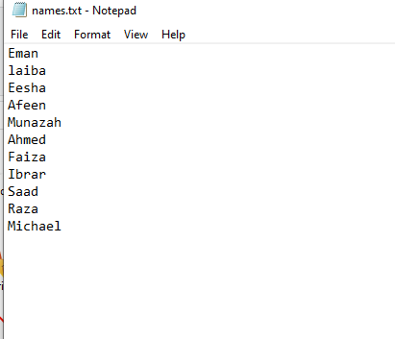

Output

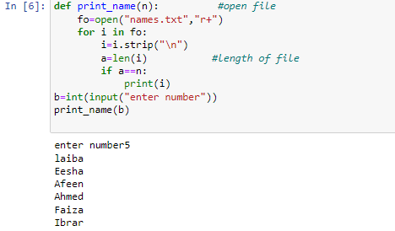

Part g:

Input

def search_key(n): #def funtion

fo=open("names.txt","r")

for line in fo: #loop to search enter name

if n in line:

return True

else:

return False

a=input("enter name to search:")

search_key(a)

Output

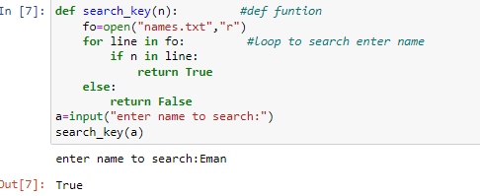

Part f:

Input

fo=open("names.txt","r") #open file to read

f=open("subject.txt","w+") #open file to write

for i in fo:

i=i.strip("\n")

i+="Programing Fundamentals lab,Programing Fundamentals,English Composition,Calculus-1"

f.write(i)

f.write("\n")

f.close()

fo.close() #closing files

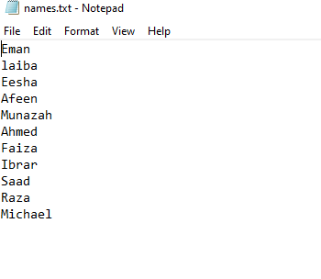

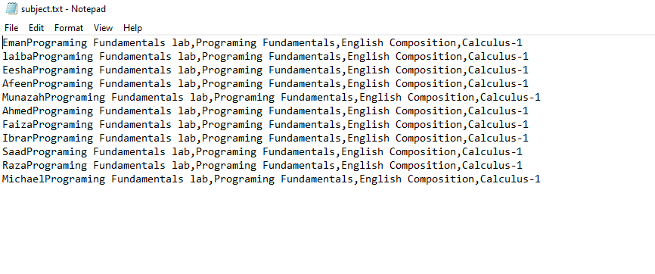

Output

Question no 2

print("Welcome to Gloria Jeans")

sum=0

ExpressoandMochaChillers=0

OverIce=0

ChocolateChillers=0

Fusion=0

question=0

while question!="n":

print("choose items from the menue") #diplaying menue

print("ExpressoandMochaChillers")

print("OverIce")

print("ChocolateChillers")

print("Fusion")

order=input("enter order:")

print("**************************************************************************")

if order=="ExpressoandMochaChillers":

print("ChocolateChillers Small Regular") #more options

print("very valina chiller 361 409 ")

print("cocoa loco 361 409 ")

print("Cocoa and cream 361 409 ")

print("Hazelnut Mocha Chiller 396 461 ")

print("Cookies Macadamia Chiller 396 461 ")

print("Italian Dolice Chiller 396 461 ")

print("Caramel Nut Chiller 396 461 ")

print("Tiramisu 399 509 ")

print("Toffee Nut Chiller 399 509 ")

print("**************************************************************************")

x=input("Enter name of drink") #user input

Size=input("size of drink:")

Quantity=int(input("Quantity of drink"))

# using dictioneries

dic1={"very valina chiller":[361,409],"cocoa loco":[361,409],"Cocoa and cream":[361,409],"Hazelnut Mocha Chiller":[396,

461],"Cookies Macadamia Chiller":[396,409],"Italian Dolice Chiller":[396,461],"Caramel Nut Chiller":[396,461],

"Tiramisu":[399, 509],"Toffee Nut Chiller":[399,509]}

if Size=="Small":

a=dic1[x][0]

if Size=="Regular":

a=dic1[x][1]

a*=Quantity

sum+=a

if order=="OverIce":

print("OverIce Small Regular")

print("Signature iced coffee 300 374 ")

print("Ice mocha 300 374 ")

print("Iced caramel latte 378 438 ")

print("Iced Americano 252 274 ")

print("Blueberry lemonade 250 291 ")

print("Lychee lemonade 250 291 ")

print("Green apple 250 291 ")

print("Peach lemonade 250 291 ")

print("Apple soda 335 368 ")

print("Lime soda 335 367 ")

print("Iced teas 239 291 ")

print("**************************************************************************")

x=input("Enter name of drink")

Size=input("size of drink:")

Quantity=int(input("Quantity of drink"))

dic1={"Signature iced coffee":[300,374],"Ice mocha":[300,361],"Iced caramel latte":[378,430],"Iced Americano":[252,274

],"Blueberry lemonade":[250,291],"Lychee lemonade":[250,291],"Green apple":[250,291],"Peach lemonade":[250,291

],"Apple soda":[335,368],"Lime soda":[335,367],"Iced teas":[239,291]}

if Size=="Small":

a=dic1[x][0]

if Size=="Regular":

a=dic1[x][1]

a*=Quantity

sum+=a

if order=="ChocolateChillers":

print("ChocolateChillers Small Regular")

print("Original iced chocolate 348 365 ")

print("White iced chocolate 348 365 ")

print("Chocolate delight 348 400 ")

print("**************************************************************************")

x=input("Enter name of drink")

Size=input("size of drink:")

Quantity=int(input("Quantity of drink"))

dic1={"Original iced chocolate":[348,365],"White iced chocolate":[348,365],"Chocolate delight":[348,400]}

if Size=="Small":

a=dic1[x][0]

if Size=="Regular":

a=dic1[x][1]

a*=Quantity

sum+=a

if order=="Fusion":

print("Fusion Small Regular")

print("Iced lime 335 365 ")

print("Apple chiller 335 365 ")

print("Chai chiller 348 400 ")

print("Green tea chiller 348 400 ")

print("**************************************************************************")

x=input("Enter name of drink")

Size=input("size of drink:")

Quantity=int(input("Quantity of drink"))

dic1={"Iced lime":[335,365],"Apple chiller":[335,365],"Chai chiller":[348,400],"Green tea chiller":[348,400]}

if Size=="Small":

a=dic1[x][0]

if Size=="Regular":

a=dic1[x][1]

a*=Quantity

sum+=a

question=input("do u want to continue (y/n)?:")

print("bill",sum)

if sum<=1000:

discount=0

elif sum>1000 and sum<2000:

discount=10

elif sum>2000:

discount=20

taxes=100

discount_amount=sum*discount/100

totalbill=(sum-discount_amount+taxes)

print("tax:",taxes)

print("Discount",discount_amount)

print("Bill",totalbill)

#opening file to display bill

f1=open("bill.txt","w")

f1.write("amount "+str(sum)+"\n")

f1.write("Tax "+str(taxes)+"\n")

f1.write("discount amount "+str(discount_amount)+"\n")

f1.write("total bill "+str(totalbill)+"\n")

f1.close() #closing file

#opening file to display bill

f1=open("bill.txt","w")

f1.write("amount "+str(sum)+"\n")

f1.write("Tax "+str(taxes)+"\n")

f1.write("discount amount "+str(discount_amount)+"\n")

f1.write("total bill "+str(totalbill)+"\n")

f1.close() #closing file

